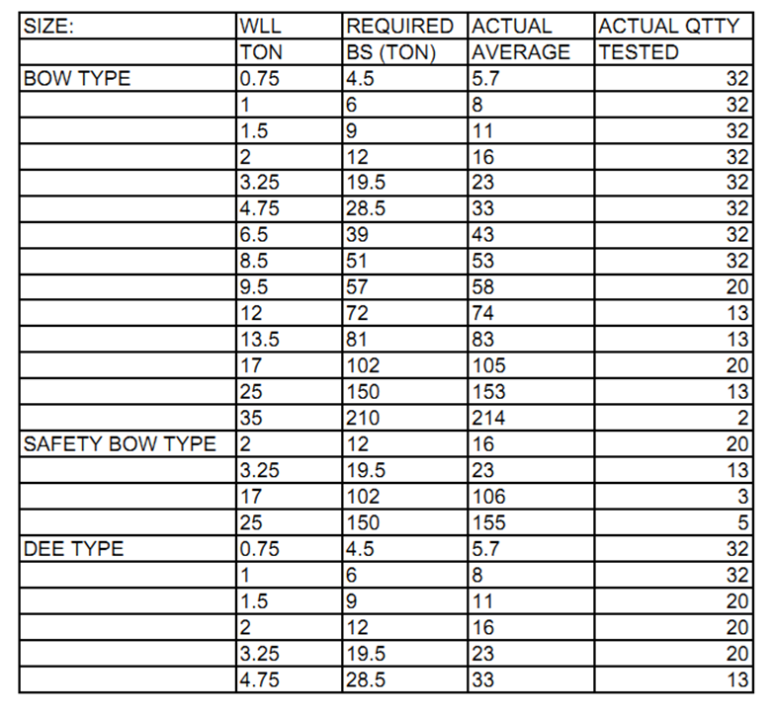

Authorised Signatory:
Manufactured, and Tested On Behalf Of:

42 Clements Avenue Bundoora
Victoria 3083 Australia Phone + 61 3 94667840 Fax: + 61 3 94667743
QYJ121012GLG
Certificate No:
This is to certify that the nominated size and quality of the following Grade S TiTAN Shackles have been inspected undergone destructive testing to comply with AS2741-2002 with following results.

TiTAN
TEST CERTIFICATE

SurfaceBatch #Test DateHDG Body & Yellow PinD1071/10/2012

